Chapter 10, Solution 16.

Consider the circuit as shown in the figure below.

V₁ j4 Ω V₂

+ V_{x} –

2∠0º A –j3 Ω 3∠45º A
5 Ω

At node 1,

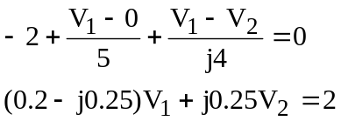 (1)

At node 2,

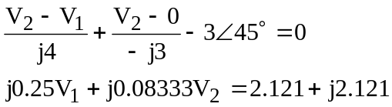 (2)
In matrix form, (1) and (2) become

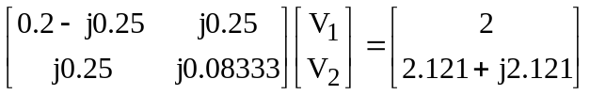

Solving this using MATLAB, we get,

>> Y=[(0.2-0.25i),0.25i;0.25i,0.08333i]

Y =

0.2000 - 0.2500i 0 + 0.2500i
0 + 0.2500i 0 + 0.0833i

>> I=[2;(2.121+2.121i)]

I =

2.0000
2.1210 + 2.1210i

>> V=inv(Y)*I

V =

5.2793 - 5.4190i
9.6145 - 9.1955i

V_{s} = V₁ – V₂ = –4.335 + j3.776 = 5.749∠138.94˚ V.

